ABCT Gets Active
ABCT Annual Fun Run
Friday October 28th
6:30am- 7:30 am

Local ABCT runners will lead an easy ~3.5 mile run through Central Park.
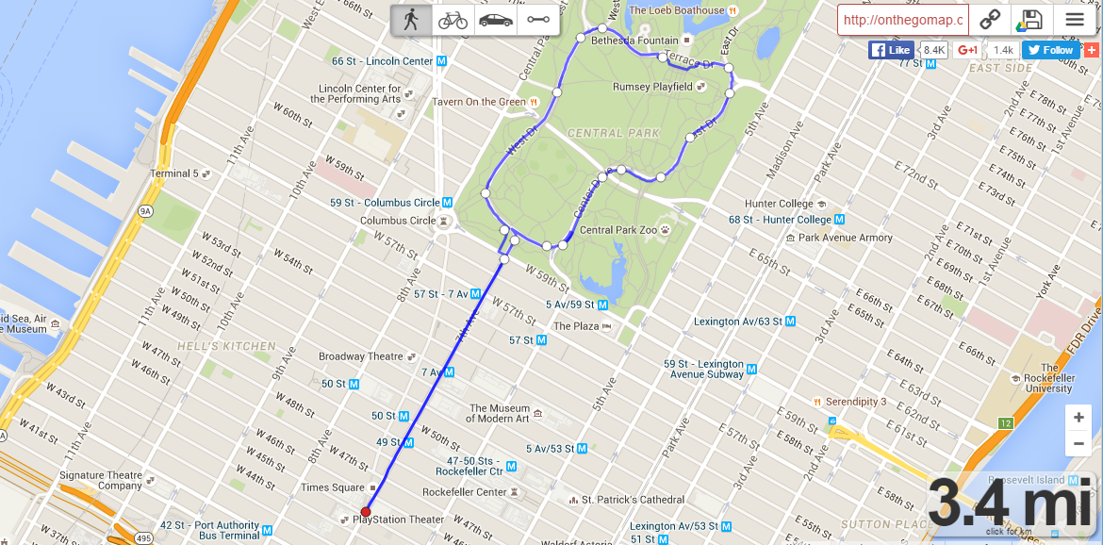
Meet at 6:20am in the Manhattan Ballroom, 8th floor. We will depart promptly at 6:30.
Please see local arrangements table for additional information and running maps of Central Park or contact the Local Arrangements Chair, Rebecca Skolnick by email at rebeccabskolnick@gmail.com.

